**PROGRAM: 1**

CREATE A TABLE EMPLOYEE WITH FOLLOWING FIELDS

ID NUMBER(10)

NAME VARCHAR(10) PRIMARY KEY

JOB VARCHAR(10)

SALARY NUMBER(10)

COMMISSION NUMBER(10)

DEPT NUMBER(10)

1. CREATE TABLE

SQL> CREATE TABLE EMPLOYEE(ID NUMBER(10),NAME VARCHAR(12) PRIMARY KEY,JOB VARCHAR(12),SALARY NUMBER(10),COMMISSION NUMBER(10),DEPT NUMBER(10));

1. INSERT INTO TABLE

SQL> INSERT INTO EMPLOYEE VALUES(&ID,'&NAME','&JOB',&SALARY,&COMMISSION,&DEPT);

Enter value for id: 1

Enter value for name: George Paul

Enter value for job: scientist

Enter value for salary: 8888888800

Enter value for commission: 1000

Enter value for dept: 7

old 1: INSERT INTO EMPLOYEE VALUES(&ID,'&NAME','&JOB',&SALARY,&COMMISSION,&DEPT)

new 1: INSERT INTO EMPLOYEE VALUES(1,'George Paul','scientist',8888888800,1000,7)

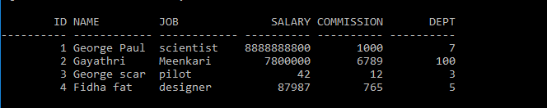

1. UPDATE TABLE

SQL> UPDATE EMPLOYEE SET JOB='ACTOR' WHERE JOB='pilot';

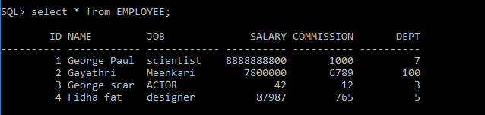

1. ALTER TABLE

SQL> ALTER TABLE EMPLOYEE ADD(DATE_OF_JOIN DATE);

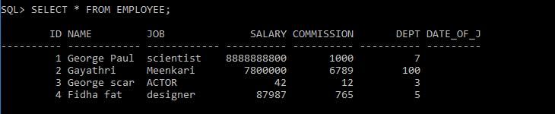

**PROGRAM: 2**

Create a table EMPP with attribute Eid(Primary key),Name,Age,Salary

SQL> CREATE TABLE EMPP(E_ID NUMBER(10)PRIMARY KEY,E_NAME VARCHAR(10),E_AGE NUMBER(3),E_SALARY NUMBER(10));

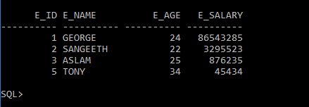

COUNT TABLE DETAILS

SQL> SELECT COUNT(E_ID)FROM EMPLO;

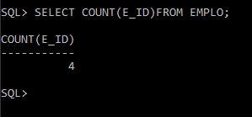

SELECT MAXIMUM AND MINIMUM VALUES IN TABLE

SQL> SELECT MAX(E_AGE)FROM EMPLO;

SQL> SELECT MIN(E_AGE)FROM EMPLO;

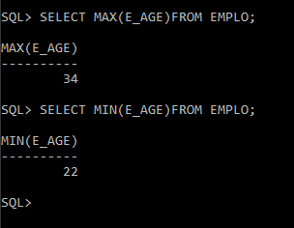

FIND AVERAGE FROM TABLE

AVERAGE SALARY

SQL> SELECT AVG( E_SALARY)FROM EMPLO;

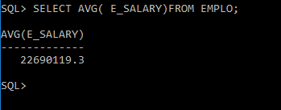

AVERAGE AGE FROM TABLE

SQL> SELECT AVG(E_AGE)FROM EMPLO;

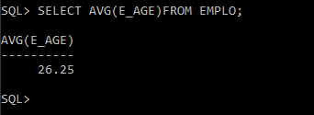

PROGRAM

CREATE A TABLE SAILORS INSERT VALUES INTO SAILORS

PRIMARY KEY-SID

SQL> CREATE TABLE SAILORS(SID NUMBER(5)PRIMARY KEY,SNAME VARCHAR(10),RATING NUMBER(2),AGE NUMBER(3));

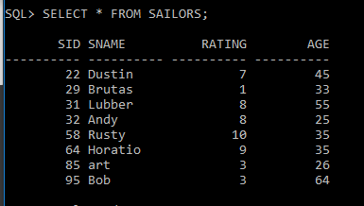

CREATE TABE BOATS AND INSERT VALUES INTO IT

PRIMARY KEY-BID

SQL> CREATE TABLE BOATS(BID NUMBER(3)PRIMARY KEY,BNAME VARCHAR(10),COLOR VARCHAR(10));

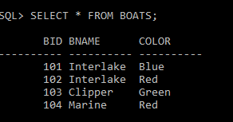

CREATE TABLE RESERVES AND INSERT VALUES INTO IT

SQL> CREATE TABLE RESERVES(SID NUMBER(3),BID NUMBER(3),DAY DATE);

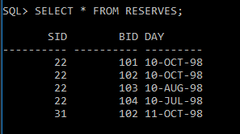

1.FIND THE NAMES AND AGES OF ALL SAILORS

SQL> SELECT SNAME,AGE FROM SAILORS;

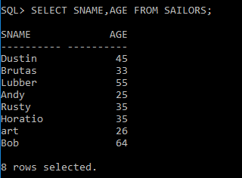

2. FIND ALL INFORMATIONS OF SAILORS WHO HAVE RESERVED BOAT NUMBER 101.

SQL> SELECT * FROM SAILORS S,RESERVES R WHERE S.SID=R.SID AND R.BID=101;

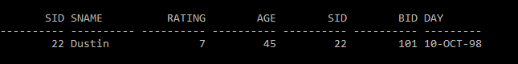

3. FIND ALL SAILORS WITH ABOVE RATING ABOVE 7

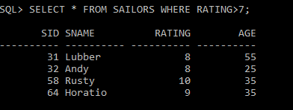

1. FIND THE NAMES OF SAILORS WHO HAVE RESERVED BOAT NO 103

